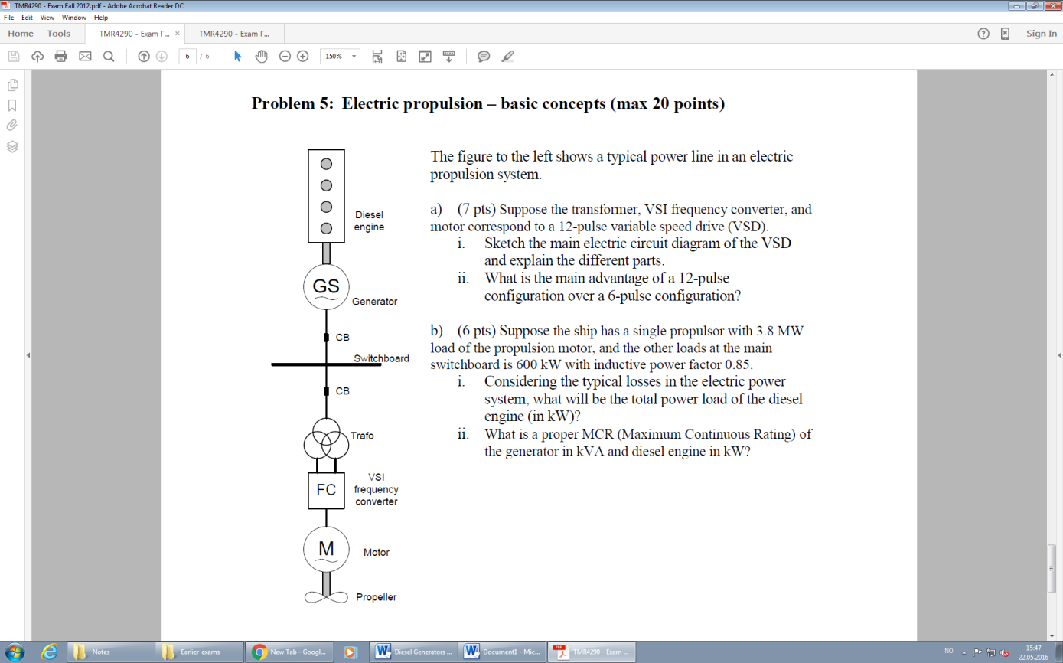**Electric propulsion – basic concepts () Theory Exam 2012**

1. (7pts) Suppose the transformer, VSI frequency converter, and motor correspond to a 12-pulse variable speed drive (VSD).
   1. Sketch the main electric circuit diagram of the VSD and explain the different parts,

**Answer:**

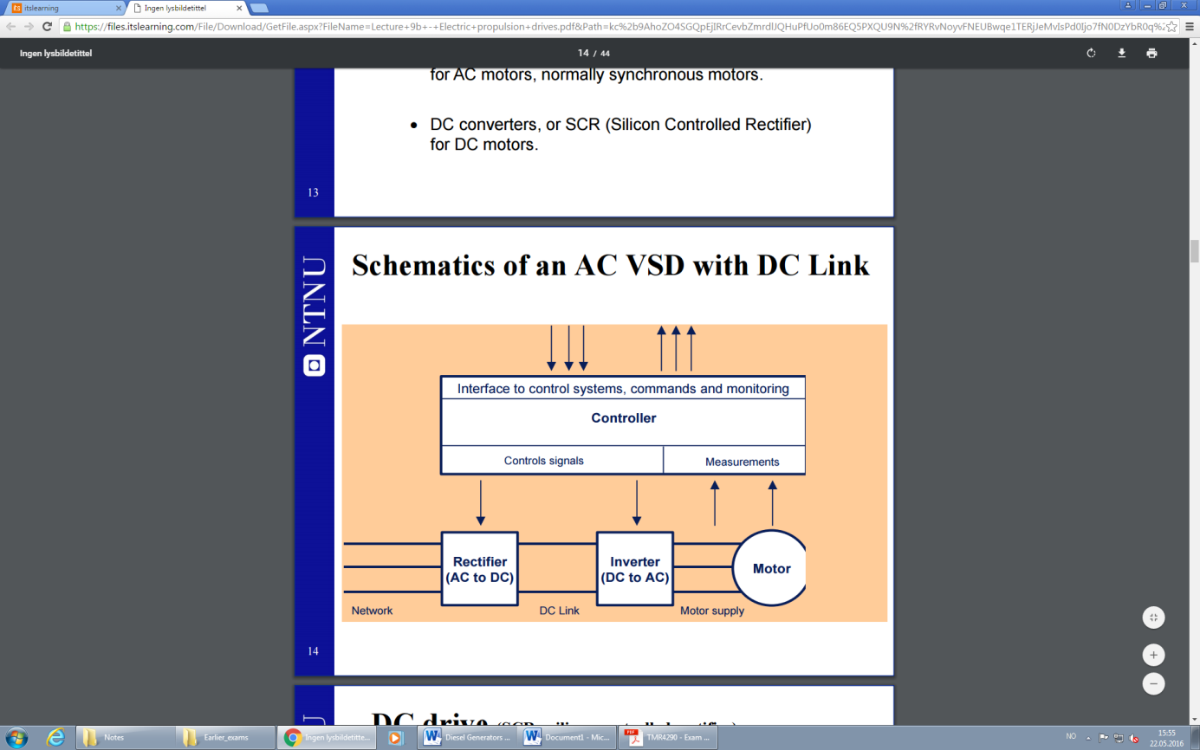Rectifier: Converts AC voltage to a DC voltage.

Inverters: Transforms the DC voltage back to a 3-phase AC voltage with desired frequency.

DC-Link: with capacitor bank for ripple reduction,

Transformer: Supplying two 3-phase supply voltages which between them are 30 degrees shifted (12-pulse).

* 1. What is the main advantage of a 12-pulse configuration over a 6 pulse configuration?

**Answer:**

A 12-pulse configuration is obtained by two 6-pulse rectifiers for which the two 3-phase supplies from the Ddy transformer are 30 degree phase shifted. This removes several harmonic frequency components and results in a significant reduction of total harmonic distortions (THD). .

1. Suppose the ship has a single propulsor with 3.8 MW load of propulsion motor, and the other loads at the main switchboard is 600kW with inductive power factor 0.85.
   1. (3pts) Considering the losses in the electric power system, what will be the total power load of the diesel engine (in kW)

**Answer:**

Propulsion motor:

* Typical losses: Motor (0.96), Frequency converter (0.98), transformer (0.99), Switchboard (0.999) 🡪 0.930

Other loads:

* Typical losses: Transformer(0.99), Switchboard(0.999) 🡪 0.989

Generator efficiency: approx. 0.96

The total power for the Diesel Engine (in kW):

* 1. (3pts) What is a proper MCR (Maximum Continuous Rating) of the generator in kVA and diesel engine in kW?

**Answer:**

Since 3.8 MW for propulsion and 600 kW for other loads are required, we get:

* Loading of the generator due to propulsion load:
$$P_{P→G} = \frac{P_{propulsion motor}}{n_{propulsion motor losses}}= \frac{3.8 MW}{0.93} =4086 kW$$

* Loading of the generator due to other loads load:

$$P_{L→G} = \frac{P_{load}}{n_{load losses}}= \frac{600 MW}{0.989} =606.7 kW$$

Thus by using the inductive power factor = 0.85 (for other loads) and VSI power factor = 0.95, we get:

$$S_{P→G} = \frac{P_{P→G} }{0.96}= \frac{4086}{0.96} =4256 kVA$$

$$S_{L→G} = \frac{P_{L→G} }{0.85}= \frac{606.7}{0.85} =713.8 kVA$$

Thus:

$P_{G} = 4692.7 kW$ and $S_{g} = 5002.8 kVA$

1. (7 pts) For a DP vessel, “Worst Case (single) Failure” (WCF) is an important term.
   1. (3pts) Explain what WCF means for a DP vessel with Equipment Class 2 and for Equipment Class 3.

**Answer:**

The worst case failure (WCF) for a DP2 vessel means the single failure that typically gives the worst consequence, within the criteria:

* Single failure in any active component or system (generators, thrusters, switchboards, remote controlled valves, etc.)
* Single failure in any static component (cables, pipes, manual valves, etc.) which is not properly documented with respect to protection and reliability.

The WCF for DP3, means the single failure that typically gives the worst consequence, within the criteria:

* All single failures considered for DP2, and any normally static component is assumed to fail.
* A single failure is all components in any one watertight compartment, due to fire or flooding.
* A single failure is all components in any one fire sub-division, due to fire or flooding.

Basically, DP2 implies only single failures in active components, while DP3 also considers single failures in passive components, any watertight compartment or flooding.

* 1. (2pts) In a Failure Mode and Effect Analysis (FMEA), one of the main tasks is to define the WCF for the DP vessel. What shall then the FMEA prove in relation to the WCF for the DP system?

**Answer:**

That position will not be lost due to WCF.

* 1. (2pts) What is the main design principle(s) (or methods) for avoiding loss of position due to any single failure in a DP system, for DP equipment class 2 and for DP equipment class 3?

**Answer:**

Use of redundancy.